**CAP 447:Data Mining & Warehouse Laboratory**

**CA_1**

**NAME: - EKHLAKH AHMAD**

**ROLL NO: - RD2215B67**

**REG NO.: - 12209166**

**GROUP: - 2**

**OBJECTIVE: - TO CREATE A COMPANY RECORD.**

**DATA OF COMPANY-**

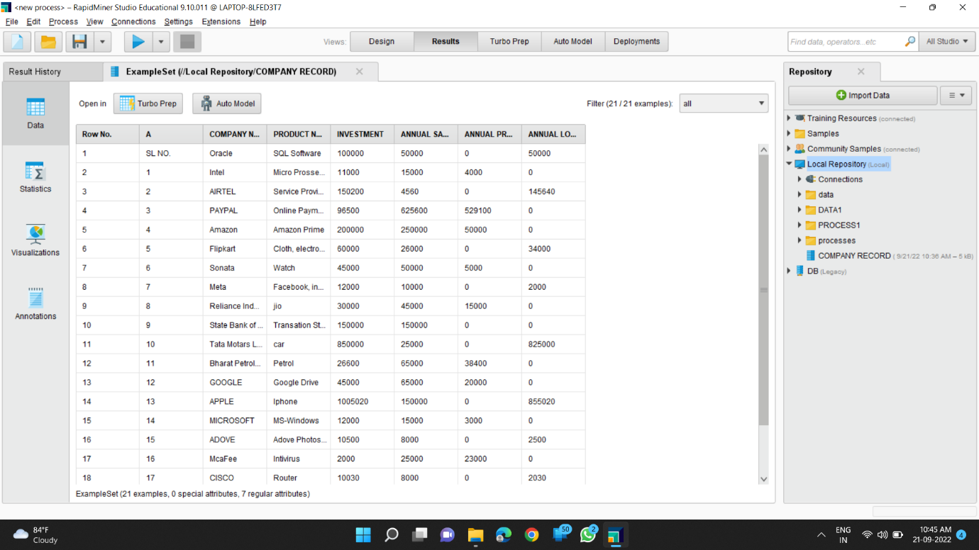

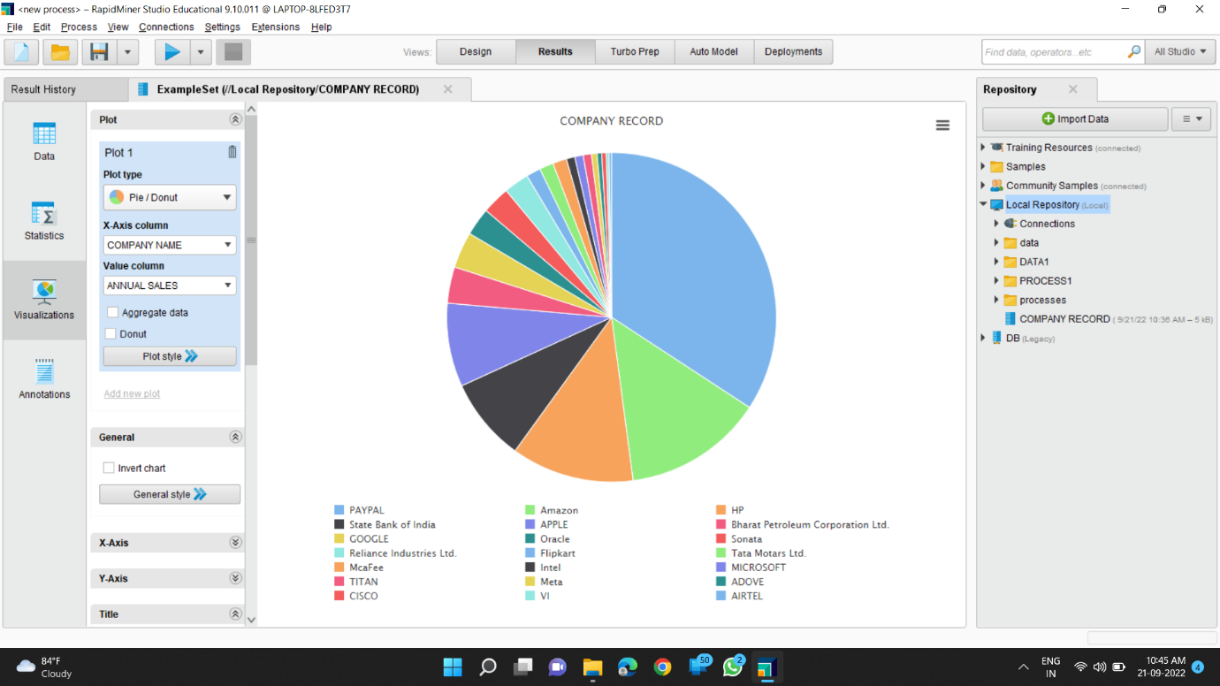**VISUALIZATIONS: -**